PT 8606
SDI GENLOCK module

The PT 8606 SDI GENLOCK module can be installed in the PT 5210 VariTime™ Digital Sync generator and PT 5230 Digital Video Generator.

Packing list:
Check that the PT 8606 option package contains the following items:
 | Description: | Item | Quantity
 | Nut for BNC Connector | 2422 034 17419 | 2
 | Lockwasher for BNC Connector | 2422 034 17421 | 2
 | Pan Head Screw M3x6 | 2522 178 31058 | 8
 | Washer Brass | 2522 600 10018 | 16
 | Distance Piece M3 | 4008 107 36490 | 8
 | Ribbon Cable with micro 20 pole connectors | 4008 105 04030 | 1
 | SDI GENLOCK module | 4008 109 83271 | 1

The system is “plug and play” meaning that when the unit is mounted no configuration is needed in order to enable the PT 8606.

Installation procedure:
- Open the PT 5210/PT 5230 by removing the top cover.
- Remove the plastic blind from the back panel for the BNC connectors marked IN OUT SDI GENLOCK.
- When options are mounted in the lower level remove the screws. Mount the 8 hexagonal spacers instead. When no options are in the lower level mount the 8 hexagonal spacers with 2 washers on each.
- Install the PT 8606 SDI genlock module.
- Mount the lockwasher and nut on the BNC connectors, do not tighten.
- Mount the 8 screws to fasten the PT 8606 (PT 8606 SDI genlock module is included), do not tighten.
- Tighten the nuts on the BNC connectors.
- Tighten the screws.
- Install the cables connecting the unit to the board in front of the module, a guide pin in each connector has to fit into a similar hole in the modules.
- Mount the top cover on the PT 5210/PT 5230.
- Place the new option type plate on the side of the generator in order to make later identification possible.

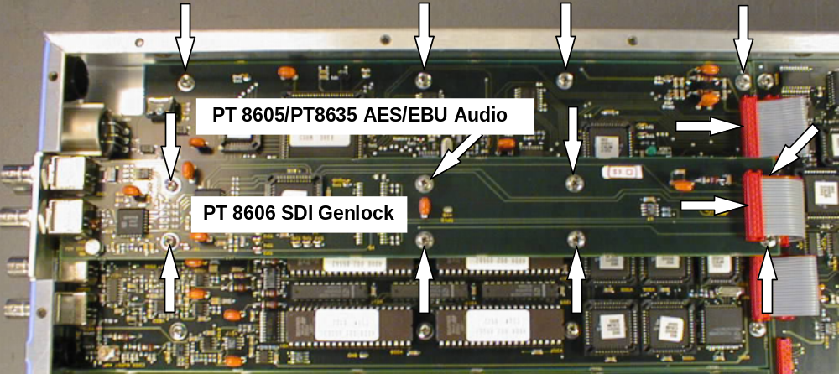
Picture 1.

Picture 1: The positioning of the PT 8605 AES/EBU Audio module and the PT 8606 SDI Genlock module in a PT 5210/PT 5230. The positioning of the hexagonal spacers are mounted below the screws fixing the
PT 8606 SDI Genlock module.

